INTERNSHIPS OPPURTUNITIES ARE UNEVENLY DISTRIBUTED
Report -2
Name: Dhanraj Prajapath
Roll no.: 24BTCE193
1.The Target User:
Students who are looking for internships.
- Age: mostly 20-to-22-year-old in the college.
- Students who are looking forward to learn skills.
- Students who want to gain work life experience before an actual job.
- Students who want to improve their portfolio for their career.
- Students who think the internships are not provided fairly and who are unable to find any internships cause of the unfairness in internship market.
- Students who fear that they won’t get placed or get a job easily if they haven’t had any internship experience.
2.Initial assumptions of the students:
Sample Assumptions:
- Students from rural areas lack skills
- Government college students are less competitive
- Students are not aware of internship platforms
- Companies prefer reputed institutions
-Students lack confidence in interviews
Assumption Table:
ID Assumption.
A1 Rural students lack technical skills.
A2 Students are unaware of LinkedIn / internship portals.
A3 Companies prefer Tier-1 colleges.
A4 Students do not apply due to fear of rejection.

3: Prepare Interview Questions
1. How do you usually search for internships?
2. Have you ever applied for internships outside your college?
3. What difficulties do you face while applying?
4. Do you receive guidance from your college?
5. Have you felt that companies prefer certain colleges?
6. What stops you from applying to more internships?
7. What support would help you the most?

4: Conduct User Interview
Instructions:
- Interview at least one student from a non-metro or government college
- Observe hesitation, confidence level, tone while discussing rejections
- Record exact statements
Sample Observation:
"Most companies don’t even shortlist students from our college."
"We don’t know where to find verified internships."

5: Create Empathy Map
Name: Abdulla Irshad.
Age:21
Occupation: student.

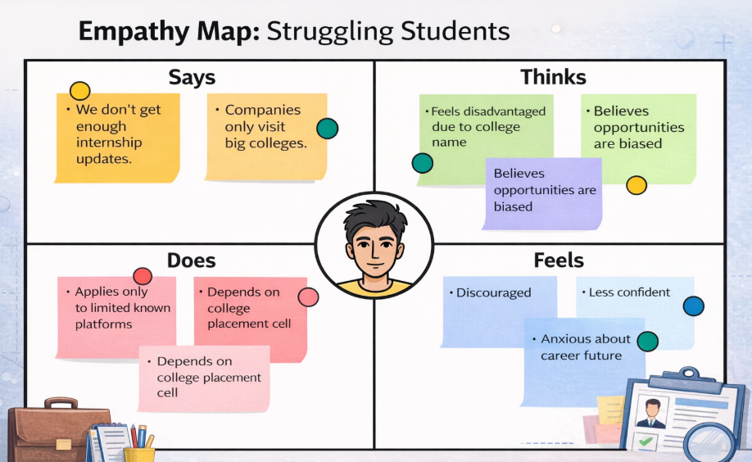
Name: Vedank Srivastava.
Age:22.
Occupation: Intern/Student.

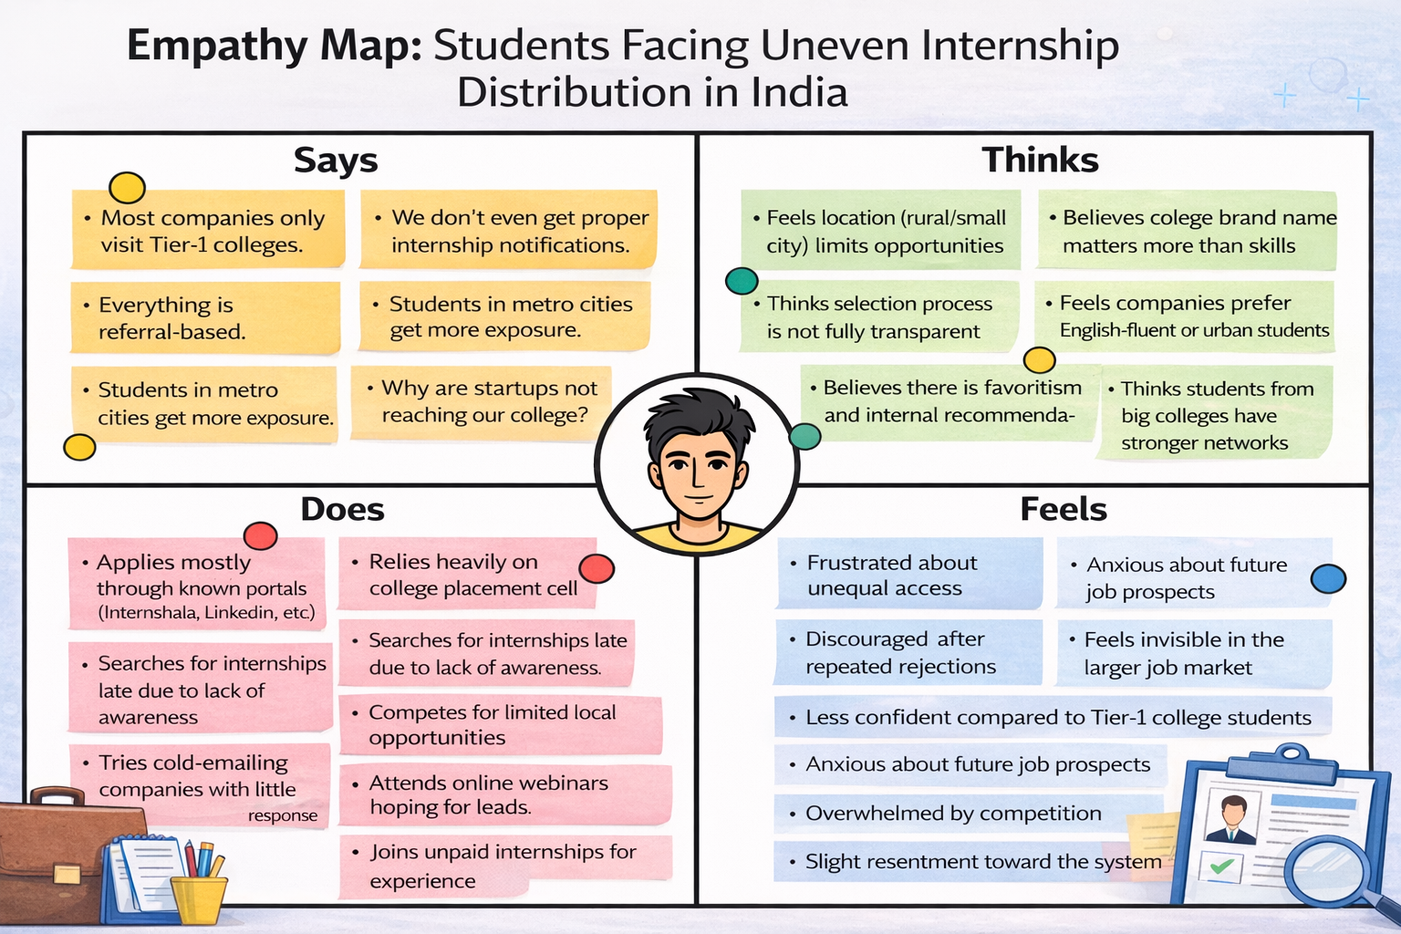

6: Validate Assumptions
Assumption | Validated? | Reason
Rural students lack skills  exposure  Unaware of platforms  Companies prefer Tier-1  Lack confidence | ❌  ✅  ✅  ✅ | Many students had good skills but lacked exposure.  Students mentioned limited awareness.  Students reported bias in shortlisting.  Students expressed fear of rejection.
- Access to information is more important than raw talent
- Institutional branding influences shortlisting
- Students need structured guidance and transparency
❌ "They are not capable"
✅ "They lack equal access and visibility"

8: Create User Persona
Name: Abdulla Irshad.
Age:21
Occupation: student.

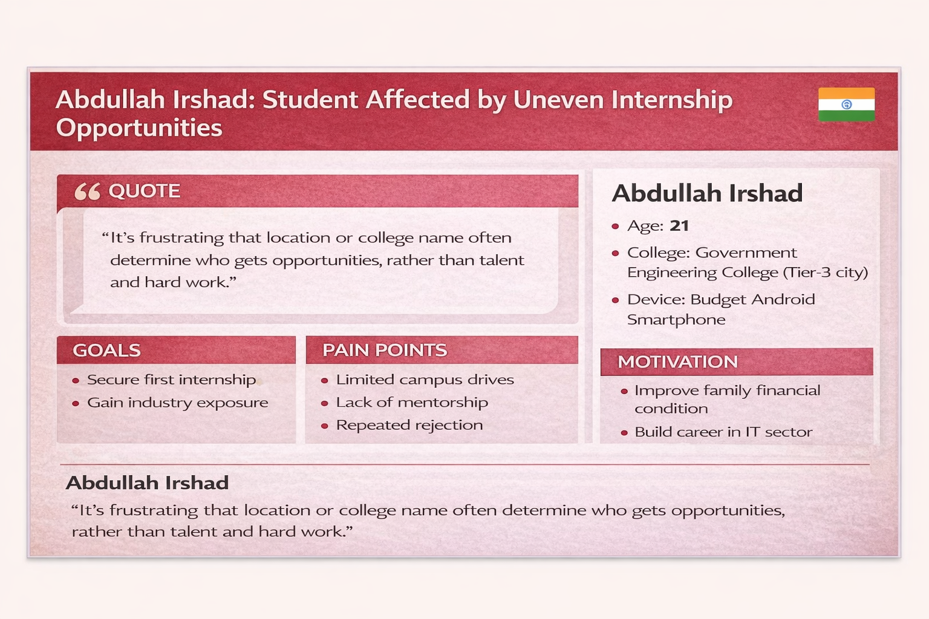

Name: Vedank Srivastava.
Age:22.
Occupation: Intern/Student.

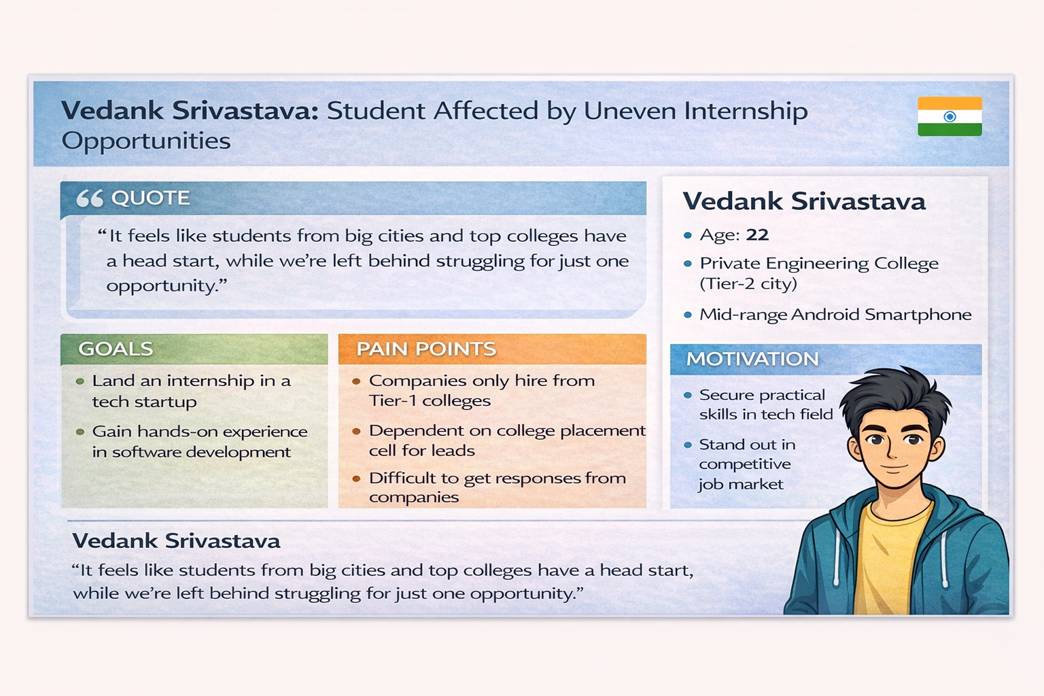

9: Translate Insights to System Needs
Insight | Software Requirement
Lack of awareness  Institutional bias  Low confidence  Limited exposure  Transparency need | Centralized internship portal  Blind skill-based matching system  Mentorship & interview preparation section  Virtual internship fairs  Application tracking dashboard

10: Reflection & Documentation
- What surprised you during the interview?
I was surprised that students were highly motivated and skilled, but systemic barriers limited their opportunities.
- Which assumption was wrong?
The belief that students lack capability was wrong; the real issue was unequal exposure and institutional bias.
- How did empathy change your thinking?
Empathy helped me see the problem from the students’ perspective, especially the emotional impact of repeated rejection.
- How will this affect your software design approach?
It encouraged me to design solutions that promote fairness, visibility, and confidence-building support systems.

